­

**How to use this book:** Begin by saying the following ‘____ I think you have something to say shall I go through the options in your communication book?’ Start by asking if ______ wants to spell the word using the alphabet chart. If not go through the headings listed below; they will be at the top of each page. Ask ____ to signal if s/he wants something on that page. _____’s signal is ______. If s/he signals for a certain page you can then turn to that page using the tabs.

Place the book so s/he can see the options on that page. You should speak each option out aloud for him/her to hear whilst pointing at them with your finger.

You then begin to go down the rows using your finger to scan through the options speaking them and allowing time for ______ to signal. It is okay to go around the options again and always offer him/her this option along with the option to go back to the contents page. When you have been through the options at the bottom of each page is an option to use the alphabet chart at the front of this book to spell out a key word. Similarly you should go through the rows (A,E,I,O,U). _______ will signal if his letter is on that row. Then you go through the letters on that row but remember if the E row is selected to offer the option E again.

Urgent and important

Television

1. Personal Care
2. Questions / chat
3. Family

Opinions



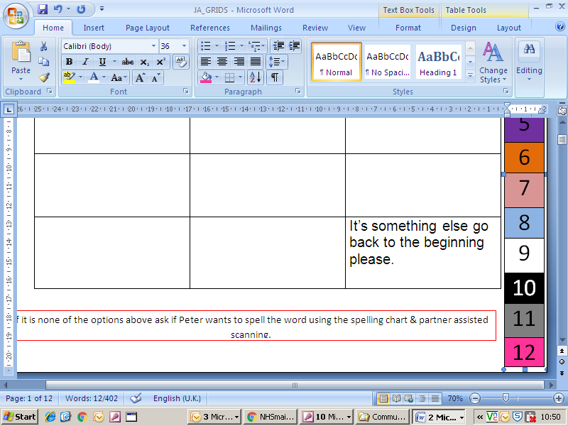



|  |  |  |  |  |  |  |  |  |  |  |  |  |  |  |
| --- | --- | --- | --- | --- | --- | --- | --- | --- | --- | --- | --- | --- | --- | --- |
| I need suction  Urgent and Important | I need the doctor | I need my medicine   |  | | --- | | 1 | | 2 | | 3 | | 4 | | 5 | | 6 | | 7 | | 8 | | 9 | | 10 | | 11 | | 12 | |
| I need to change my position. | I need my feet moving | I need my hand moving |
| I am too hot/too cold | Have you remembered we have an appointment today? | Have you locked the door? |
| I need the toilet | I am in pain | It’s something else go back to the beginning please. |

If it is none of the options above ask if _____ wants to spell the word using the spelling chart & partner assisted scanning.

|  |
| --- |
| 1 |
| 2 |
| 3 |
| 4 |
| 5 |
| 6 |
| 7 |
| 8 |
| 9 |
| 10 |
| 11 |
| 12 |

TV Programmes

|  |  |  |
| --- | --- | --- |
| What’s on today? | Change the channel please | I don’t like this one |
| Change the volume please | Turn it on / off | I like this one |
| I want to watch…(please use my alphabet chart so I can tell you) | What’s been happening in this show? | Who’s that? |
|  |  | It’s something else go back to the beginning please. |

If it is none of the options above ask if _____ wants to spell the word using the spelling chart & partner assisted scanning.

|  |
| --- |
| 1 |
| 2 |
| 3 |
| 4 |
| 5 |
| 6 |
| 7 |
| 8 |
| 9 |
| 10 |
| 11 |
| 12 |

Personal Care

|  |  |  |
| --- | --- | --- |
| Wipe my nose please | I want to shave | Help me clean my teeth please |
| Can you comb my hair please? | I have an itch |  |
|  |  |  |
|  |  | It’s something else go back to the beginning please. |

If it is none of the options above ask if _____ wants to spell the word using the spelling chart & partner assisted scanning.

|  |
| --- |
| 1 |
| 2 |
| 3 |
| 4 |
| 5 |
| 6 |
| 7 |
| 8 |
| 9 |
| 10 |
| 11 |
| 12 |

Questions / Chat

|  |  |  |
| --- | --- | --- |
| How are you / them? | What are you / they doing? | Who? |
| Do you know? | Can you help? | Why are you doing that? |
| Can we do something today? | Where are we / you going? | What have you been up to? |
| I love you |  | It’s something else go back to the beginning please. |

If it is none of the options above ask if _____ wants to spell the word using the spelling chart & partner assisted scanning.

|  |
| --- |
| 1 |
| 2 |
| 3 |
| 4 |
| 5 |
| 6 |
| 7 |
| 8 |
| 9 |
| 10 |
| 11 |
| 12 |

Family

|  |  |  |
| --- | --- | --- |
| How’s…… (use my alphabet chart please) | Is anyone coming to see me today? | How are my children? |
| I love you |  |  |
|  |  |  |
|  |  | It’s something else go back to the beginning please. |

If it is none of the options above ask if _____ wants to spell the word using the spelling chart & partner assisted scanning.

|  |
| --- |
| 1 |
| 2 |
| 3 |
| 4 |
| 5 |
| 6 |
| 7 |
| 8 |
| 9 |
| 10 |
| 11 |
| 12 |

Opinions

|  |  |  |
| --- | --- | --- |
| I don’t like it | I like it | There’s a problem with…(please use my alphabet chart) |
| It needs changing | It’s okay | I agree |
| I disagree | Thank-you |  |
|  |  | It’s something else go back to the beginning please. |

If it is none of the options above ask if _____ wants to spell the word using the spelling chart & partner assisted scanning.

|  |
| --- |
| 1 |
| 2 |
| 3 |
| 4 |
| 5 |
| 6 |
| 7 |
| 8 |
| 9 |
| 10 |
| 11 |
| 12 |

|  |  |  |
| --- | --- | --- |
|  |  |  |
|  |  |  |
|  |  |  |
|  |  | It’s something else go back to the beginning please. |

If it is none of the options above ask if _____ wants to spell the word using the spelling chart & partner assisted scanning.

|  |
| --- |
| 1 |
| 2 |
| 3 |
| 4 |
| 5 |
| 6 |
| 7 |
| 8 |
| 9 |
| 10 |
| 11 |
| 12 |

|  |  |  |
| --- | --- | --- |
|  |  |  |
|  |  |  |
|  |  |  |
|  |  | It’s something else go back to the beginning please. |

If it is none of the options above ask if _____ wants to spell the word using the spelling chart & partner assisted scanning.

|  |
| --- |
| 1 |
| 2 |
| 3 |
| 4 |
| 5 |
| 6 |
| 7 |
| 8 |
| 9 |
| 10 |
| 11 |
| 12 |

|  |  |  |
| --- | --- | --- |
|  |  |  |
|  |  |  |
|  |  |  |
|  |  | It’s something else go back to the beginning please. |

If it is none of the options above ask if _____ wants to spell the word using the spelling chart & partner assisted scanning.

|  |
| --- |
| 1 |
| 2 |
| 3 |
| 4 |
| 5 |
| 6 |
| 7 |
| 8 |
| 9 |
| 10 |
| 11 |
| 12 |

|  |  |  |
| --- | --- | --- |
|  |  |  |
|  |  |  |
|  |  |  |
|  |  | It’s something else go back to the beginning please. |

If it is none of the options above ask if _____ wants to spell the word using the spelling chart & partner assisted scanning.

|  |
| --- |
| 1 |
| 2 |
| 3 |
| 4 |
| 5 |
| 6 |
| 7 |
| 8 |
| 9 |
| 10 |
| 11 |
| 12 |

|  |  |  |
| --- | --- | --- |
|  |  |  |
|  |  |  |
|  |  |  |
|  |  | It’s something else go back to the beginning please. |

If it is none of the options above ask if _____ wants to spell the word using the spelling chart & partner assisted scanning.

|  |
| --- |
| 1 |
| 2 |
| 3 |
| 4 |
| 5 |
| 6 |
| 7 |
| 8 |
| 9 |
| 10 |
| 11 |
| 12 |

|  |  |  |
| --- | --- | --- |
|  |  |  |
|  |  |  |
|  |  |  |
|  |  | It’s something else go back to the beginning please. |

If it is none of the options above ask if _____ wants to spell the word using the spelling chart & partner assisted scanning.